**Day 3 Assignment**

**1.Create a class component called “Gitam”, that class component needsto print “Welcome to Gitam”. Export the class Component to App.js and execute the program.**

**Gitam1.js**

import React,{Component} from 'react';

class Gitam1 extends Component

{

    render()

    {

        return(

            <h1>Welcome to Gitam</h1>

        )

    }

}

export default Gitam1;

**App.js**

import './App.css';

//import University from './University';

//import Classstate from './Classstate';

import Gitam1 from './Gitam1';

function App()

{

return(

  <div>

  <Gitam1/>

  </div>

);

}

export default App;

**2. In App.js , inside the App function create one function called Banana and it need to return your name .**

**Create a button called Gitam , whenever Gitam is clicked, the function should be called.**

**App.js**

import './App.css';

//import University from './University';

//import Classstate from './Classstate';

function App()

{

  function Banana()

  {

    alert("Function Called");

    return(

      <div>

        <h1>My Name is Koushik</h1>

      </div>

    )

  }

  return(

    <div>

       <button onClick="{Banana}">Gitam </button>

       <Banana/>

    </div>

  )

}

export default App;

**Output :**

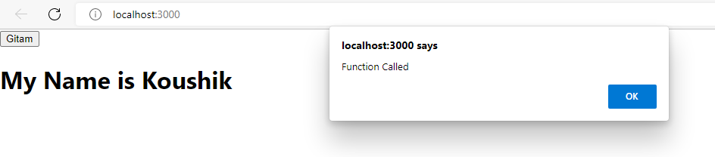

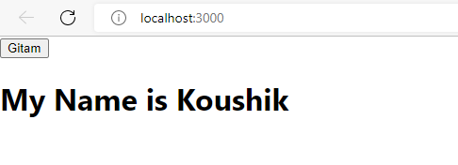

**3. In App.js , create a variable item, pass the value University to that variable and print the value of that variable to the output screen two times by using the variable.**

**App.js**

import './App.css';

//import University from './University';

//import Classstate from './Classstate';

function App()

{

  var item="University";

return(

  <div>

    <h1>{item}</h1>

    <h1>{item}</h1>

  </div>

);

}

export default App;

**Output:**

